Inhoud
1 Nota’s en Eigendommen 1
2 Media 1
2.1 Data model 1
2.2 Media Database Application 2
2.2.1 goedegep.media.mediadb.albuminfo 4
3 Rolodex 6
4 Unit Converter 6
5 Vacations 6
6 PCTools 6
7 External Projects 6
7.1 Gluon Maps 6

TEMP Dialogs

Swing
OptionDialog
AppDialog
javax.swing.JDialog
MessageDialogType
MessageDialog
My Swing implementation provides:
- AppDialog
Abstract common parent. Contains no real functionality.
- MessageDialogType
Specifies the type of MessageDialog. Value: ERROR, WARNING.
- MessageDialog
This is an information dialog. Type only specifies the icon (ERROR, WARNING), the icon can also be set to anything else.
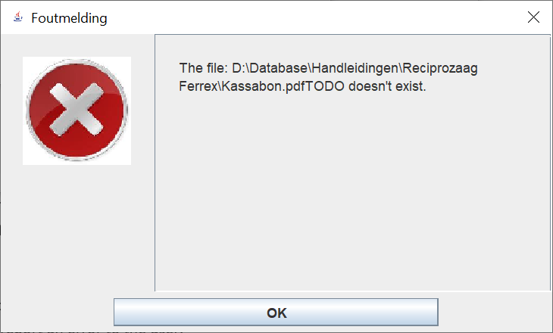
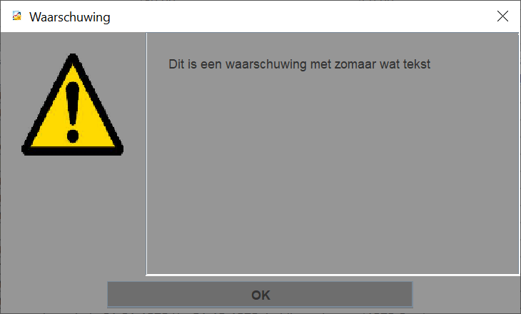
- OptionDialog
The user is offered a number of options via a number of radio buttons.
There’s a single ‘OK’ button.
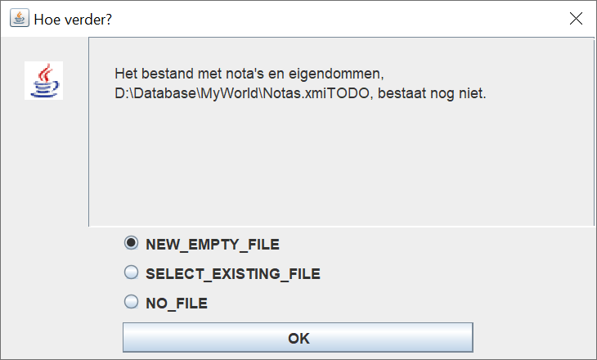
- BestandReferentieDialog
This is a dialog to enter a BestandReferentie.
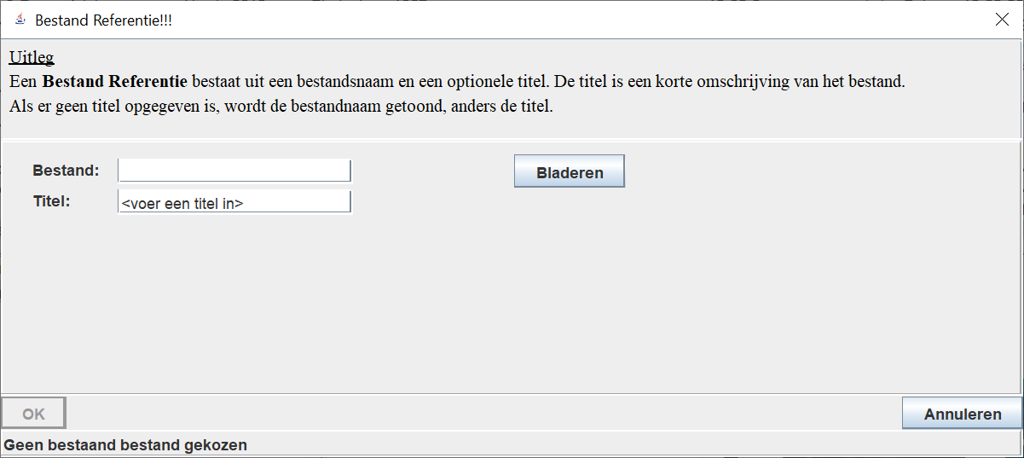

My Current JavaFx solution

JavaFx standard available dialogs

What do I need?
General layout:
- Title in title bar (parameter)
- Icon in title bar (customization)
- Icon to indicate type of dialog:
  - Error dialog: X
  - Option dialog :?
Dialog types:
- Error dialog (information only)
Use case: report an error to the user.
  - Icon to indicate type of dialog: X
  - text to explain the error
  - OK button
- Warning dialog (information only)
Use case: warn the user about something.
  - Icon to indicate type of dialog: !
  - text with the warning
  - OK button
- Option dialog
Use case: user has to select one of several options, before the application can continue.
  - Icon: ?
  - text to explain the option selection
  - radio buttons to select option
  - OK button
  - Do I need a cancel button? (not for now)
- FileReference dialog
Use case: create a new FileReference.
  - No icon
  - text to explain the FileReference
  - fields to select a file
  - fields to specify a title
  - OK button – FileReference will be created
  - Cancel button – No action.

Solution
- Stay as close as possible to the JavaFx dialog API.
- Error dialog -> Alert, type is ERROR
- Warning dialog -> Alert, type is WARNING
- Option dialog -> ChoiceDialog (combo box instead of radio buttons).
- FileReference dialog: to be created.

Nota’s en Eigendommen
This component has sub components, so it uses a component launcher, class NotasEnEigendommenMenuWindow.

Media

Data model
Albums/tracks
Track are stored as a separate list.
An Album has discs.
Track things to handle:
- commercial disc
  - references to the tracks needed, for a track listing of the disc.
Covered by a list of TrackReferences.
  - if I have the complete album, information about where (can be per track)
Needed to play the tracks.
TrackReferences -> Tracks -> MyTrackInfo -> iHaveOn
  - if I have tracks as part of my own compilation, information about which tracks on which compilation (has to be part of MyInfo)
TrackReference.myInfo. compilationTrackReference
  - if I have one or more tracks as part of a Collection, information about which tracks in which Collection (has to be part of MyInfo).
Is part of the MyInfo per track.
- MyCompilation album
By definition, I have all tracks.
  - references to the tracks needed, for a track listing of the disc
The trackReferences
  - information about where (can be per track)
Needed to play the tracks. Covered by IHaveOn/Collection of the track
  - per track a reference to the track of the original album (has to be part of MyInfo)
covered by originalAlbumTrackReference
- Separate tracks, stored in Collections
  - References to the tracks needed, for a track listing (per Collection)
These are all tracks in MediaDb.track, which have collection set to a specific collection.
  - References to the track needed to be able to play them
Find in complete track list, or collection.
  - A possible reference to the album it came from
Covered by referredBy
For a track of a disc the following applies:
- commercial disc
Each track is a TrackReference to a Track.
- my own compilation disc
Each MyTrackInfo.TrackReference
Updated data model:

Media Database Application
Hi
AlbumsTable
albumsTable
MediaDbWindow
TracksTable
goedegep.media.mediadb.app.guifx
goedegep.media.model.mediadb
goedegep.appgenfx
tracksTable
goedegep.util
AlbumDiscLocationInfo
goedegep.media.mediadb.app
goedegep.media.mediadb.albuminfo

Description per package:
- goedegep.media.mediadb.app.guifx
The GUI of the application.
- goedegep.media.mediadb.app
The functionality of the application (as far as not covered by the other packages).
- goedegep.media.mediadb.albuminfo
This package has all the knowledge of the structure and file name conventions of the AlbumInfo files. Information read from the AlbumInfo files is stored in the MediaDb data model, and a MediaDb data model can be written to AlbumInfo files.
- goedegep.media.model.mediadb
The data model of the media database.
TODO: to be renamed to goedegep.media.mediadb.model.

goedegep.media.mediadb.albuminfo
This package has all the knowledge of the structure and file name conventions of the AlbumInfo files. Information read from the AlbumInfo files is stored in the MediaDb data model, and a MediaDb data model can be written to AlbumInfo files.
AlbumInfoHandler
albumInfoHandler
AlbumInfoFilesReader
AlbumInfoErrorInfo
goedegep.media.mediadb.albuminfo
goedegep.media.model.mediadb
goedegep.util
AlbumInfoError
errorCode
errors
- AlbumInfoFilesReader
This class reads 'AlbumInfo' files and stores the information in a MediaDb structure. It also writes the information from a MediaDb structure to 'AlbumInfo' files.
This class has the knowledge of the filename conventions. For reading it scans the folder with 'AlbumInfo' files. For each file it calls an AlbumInfoHandler to parse the file.
- AlbumInfoHandler
This class reads 'AlbumInfo' XML files and stores the information in a MediaDb model.
The schema for these files is defined in the xsd file "D:\Database\Muziek\Albums\AlbumInfo.xsd".
The parser can generate errors of the following types: AlbumInfoErrorInfo, goedegep.util.ParseException.

Rolodex
This component has sub components, so it uses a component launcher, class RolodexMenuWindow.

Unit Converter
This component is a single application, where the main class is UnitConverterWindow.

Vacations
This component is a single application, where the main class is VacationsWindow.

PCTools
This component has sub components, so it uses a component launcher, class PCToolsMenuWindow.
The sub components are:
- FileFinder
- FilesControlled

External Projects

Gluon Maps
This project provides a map view.
MapPoint
MapView
javafx.scene.layout.Region
BaseMap
baseMap
MapLayer
layers
javafx.scene.Parent
javafx.scene.Group
JavaFx
com.gluonhq.maps
- com.gluonhq.maps
  - MapPoint
This class provides a point on a map, which are just the latitude/longitude coordinates.
  - MapView
This is the top UI element of the map component.
This class is mainly a wrapper around a BaseMap.
  - MapLayer
A MapLayer can be added on top of a BaseMap (which provides the map tiles).
This class only provides the framework for map layer. Any specific map layer shall extend this class and override the methods: initialize() and layoutLayer().
- com.gluonhq.impl.maps
  - BaseMap
The BaseMap provides the underlying map tiles. On top of this, additional layers can be rendered.

